SECTION A - WEBSITE PLANNING & DOCUMENTATION

**1. Website Specifications**

**[a].**

Warner Bros Mission Statement:

Is to make a positive impact on the world through initiatives that encourage youth to be storytellers, create access and opportunities for new voices, and drive sustainable production. **(Mission Statement Academy 2023).**

This mission statement must be evident in the warner bros website as well. This is because whatever information regarding businesses, especially ones as large as this one, can and should be found online for user convenience. Consequently, by reaching out to people online through a website, we must cater to a large audience with varying interests. An example would be parents going to the warner bros website to find a movie or TV series that’s suitable for children. How do we present this content? Would it be done the same way we’d present content catered to people over the age of 18?

After taking this into consideration, the website should be able to cater to the various kinds of people using. In a universal sense. When the goal of the website is to provide an indiscriminatory service, we absolutely must present the content in a straightforward and accessible format.

**[b].**

Therefore the Segmentation of the company is from movies, television shows and superhero series. The target market follows young teens, young adults and kids on the basis of genre. The positioning of Warner Bros is the Franchising of films using a fully digital supply chain. **(Aditya Shastri 2022).**

As stated above, Warner Bros leans more towards serving the younger demographic of the population. These are further broken down into demographics such as gender so as it really cater to as many individuals as possible. Targeting the younger demographic is both advantageous and disadvantageous. Its advantageous in the sense that younger people tend me to be a lot more computer literate when compared top other age groups. However, they also tend to be a bit more sensitive so being careful of what is put on the site is important.

Kids although computer literate, they are only able to digest small and very simple content. A lot of colours, images, and moving pictures tends to be more to their liking. We could say that they have a next to basic technical aptitude. Both the male and female members of this target are more into animated pieces, that more often than not contain music and other media they can easily follow along

Teenagers are exceptionally computer literate. So, content must be apprehensive and eye catching whilst also not being too childlike. It’s a more difficult audience to cater to since they are going through a transitional process in their lives. Majority of them have an intermediate level of technical aptitude. The male demographic tends to lean towards superhero content or media with a lot of thrill and action. The female demographic on the other hand leans towards simple and more grounded/ realistic content that focus on real life settings.

Young adults are more mature and by now are much more comfortable with technology. They’re interested in more mature content and just want their content given to them straightforward but user-friendly way that does not waste their time. If they have been using technology for a good portion of their lives, they should have a higher technological aptitude than the other members of the target audience. the demographics become trickier as this stage in their life, they are just more interested in watching whatever tickles their fancy regardless of genre. So with this kind of setting, the content should be presented in a more unisex sort of way.

**[c].**

**2. Information Design & Taxonomy**

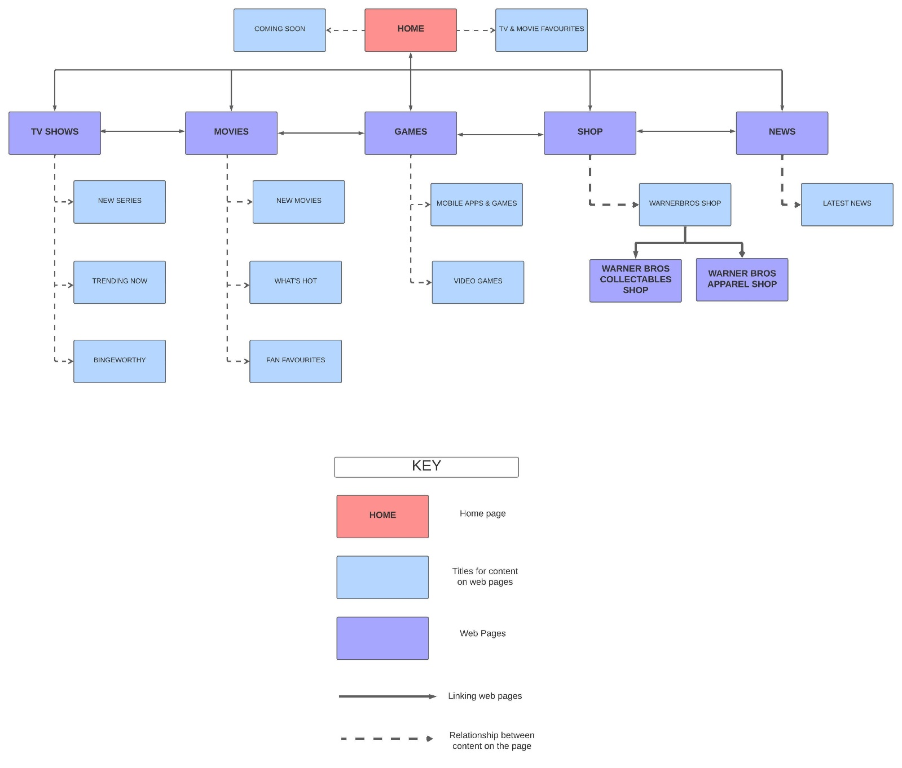

**3. Page Template Design**

***Home Page:***

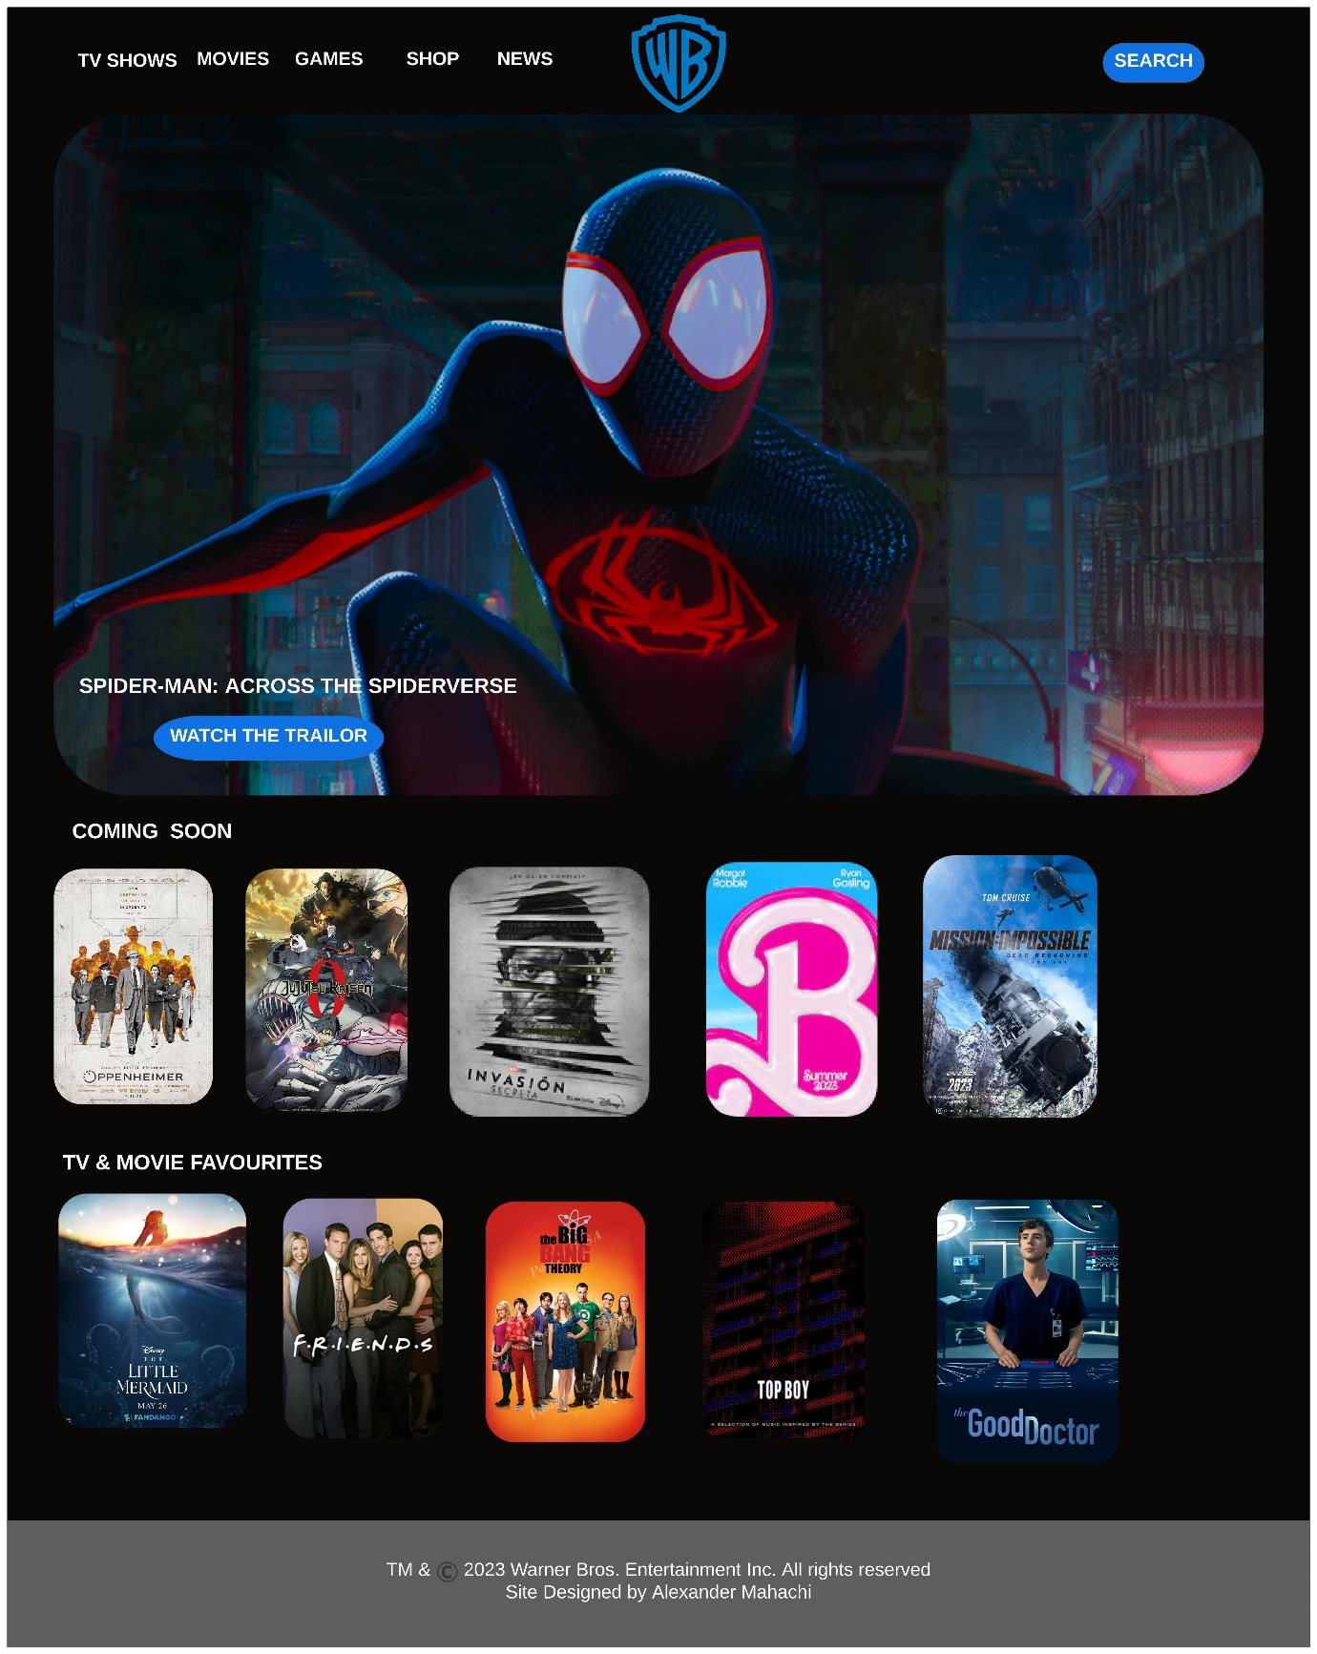

***TV Shows Page:***

***Movies Page:***

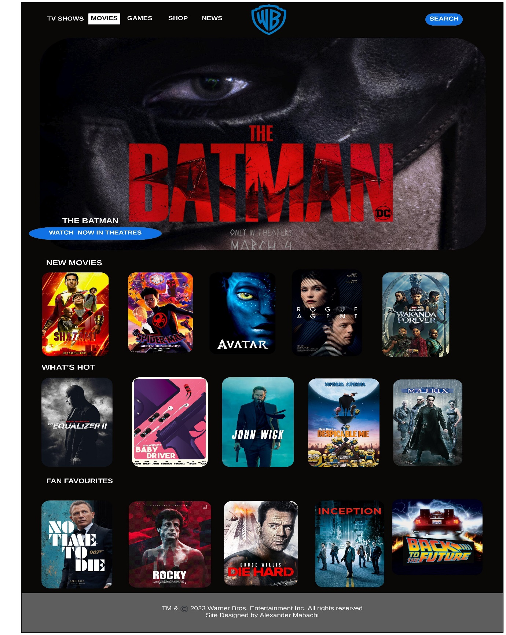

***Games Page:***

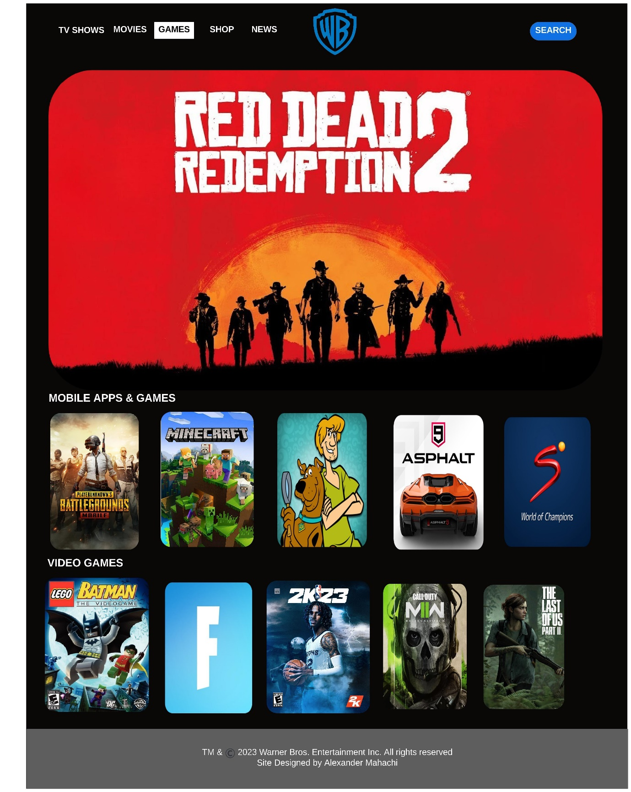

***Shop page:***

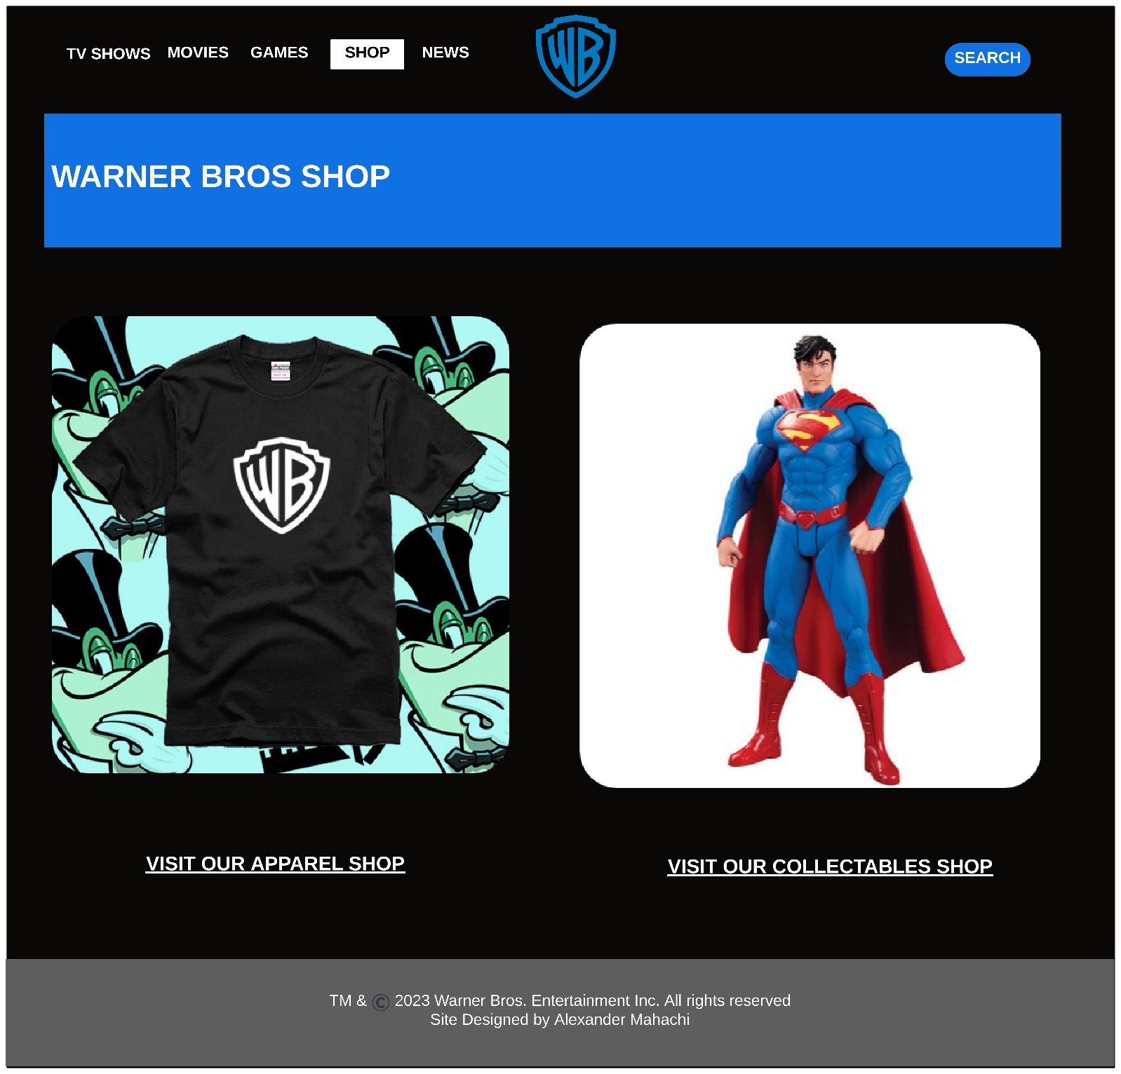

***News Page:***

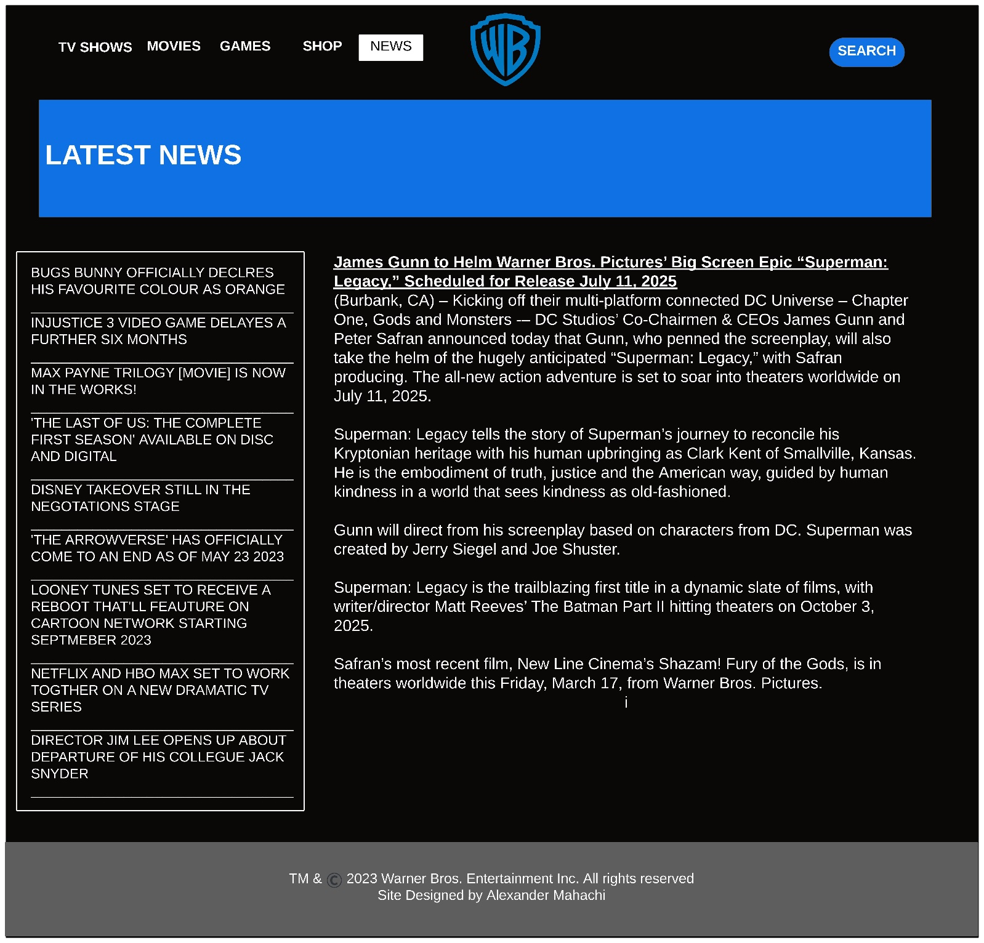

**4. Technical Brief**

**5. Quality Assurance**

**6. Publishing & Promotion**

**7. Future developments/Recommendations**

**REFERENCE LIST**

Mission Statement Academy. 2023. *Warner Brothers Mission Statement.*[Online*]* Available from: <https://mission-statement.com/warner-brothers-mission/> .[Accessed Date: 26 May 2023].

Aditya Shastri. (2022). Detailed Marketing Strategy of Warner Bros with Company Overview. *Marketing Strategy of Warner Bros: Segmentation, Targeting, and Positioning.* Available from: <https://iide.co/case-studies/marketing-strategy-of-warner-bros/#:~:text=Therefore%20the%20Segmentation%20of%20the,a%20fully%20digital%20supply%20chain>. [Accessed Date: 26 May 2023].